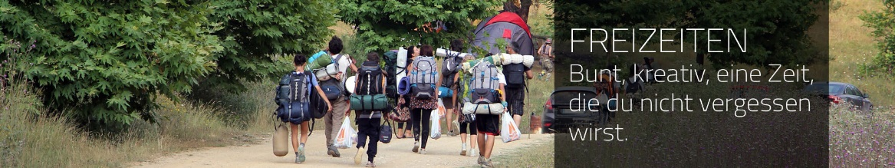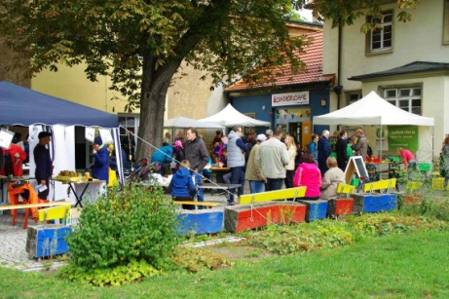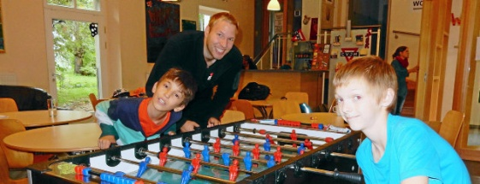

**“Integrate Yourself in the Society through Volunteering”**

International Youth Exchange Project in Thüringen (Germany)

Live a unique experience in Erfurt along with other young volunteers from France, Germany and Russia!

This project will give you the opportunity to discover Thuringia, great initiatives of the local YMCA, to get in contact with local population and share your knowledge of civic engagement.

During a week next April, young people from those 3 countries will have the opportunity to be involved in a project, which aims to build cross-cultural dialog, understanding and friendships. The main goal of this project is to encourage international youth exchange, civic engagement and to foster volunteering. Through sharing ideas and best practices, conference and discussions, study visits and workshops, they will get tools to become more socially engaged. It will also be a great opportunity to learn more about different cultures in these different countries.

We will use informal methods to encourage participants learn more about customs, history, culture and tradition of other participating countries. Through outdoor activities, excursion or sightseeing, we will facilitate and encourage communication, mutual understanding, tolerance and solidarity among the participants. It will also help to break stereotypes and prejudices, and build international teams of like-minded socially responsible young people for future joint projects.

**Date**: From the 13rd of April to the 20th of April 2019

**Participants:** 18-26 years old – 8 from each country

**Travel reimbursement:** Up to 300€ - If you are from Russia: Up to 130€, if you are from France and 100€ if you are from Germany: Please ask for the exact amount beforehand.

**Venue:** Germany (Thuringia)

**Participation fees:** Russian participants: 20€ - French and German participants: 80€

**Visa costs:** 50-80€ at the charge of the participant.

*(As soon as you participation is confirmed, we will send you a visa invitation and we advise you to contact the German embassy ASAP)*

**Language:** The conference will be hold in English! During daily activities you will have the opportunity to improve your German, French and Russian skills!

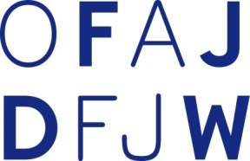**The project is financed by**

**What to bring:**

**Documents you should carry with you:**

* Valid passport and visa or ID for residents of the EU
* European Health Insurance Card (EHIC) and/or certificate paper

**Individual equipment needed:**

* Warm and rain clothes (the weather can change quickly, it may rain) – In April the weather is still fresh.
* Trainers/Sneakers (standard sport shoes). We will move, walk, run!

**For the international evening:**

* One (or more) culinary specialty of your country/region/district. We will use it for an 'international evening', during which each national group will present its country to the others participants.
* A flag and explanations about it: when was it created? What does it means?
* Music of your country which you would like to share with the other participants.
* Clothes, picture, painting or postcard or anything typical of your country.

**Last but not least**: bring whatever you have which may contribute to create team spirit. Board games, music of your country, books to share, magic tricks, music instruments, sports equipment... Don't forget that the success of such an event mainly depends on the motivation and the involvement of the participants themselves, that’s to say, in other words… you!!

Keep in mind that we have just little mobile/internet coverage on the camp site: take with you what you need (pictures/music/information…) before you come!

Please don’t book your flight/train before getting in contact with us!

**Contact of the Coordination Team:**

**Germany:**

Lutz Zieger

0049 17 35 49 04 88

[zieger@cvjm-erfurt.de](mailto:zieger@cvjm-erfurt.de)

**France:**

Louis Schweblin

00 33 (0)1 45 83 62 63

projets@ymca.fr

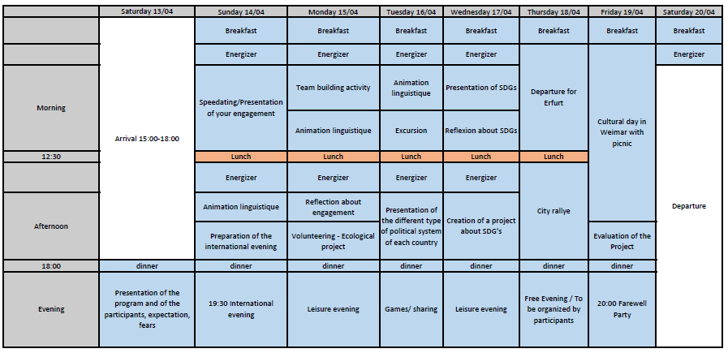**Program (you will receive the final program in March)**